Introduction
The main objectives of the lab are conducting a survey and mapping various point with some calculations. all the calculation are shown with formulas. The objectives of the paper are mastering various point taking techniques on levelling. Avoids methods will be used throughout the process of levelling to show how useful the equipment is used to ensure sufficiency in the work.
The main concern of the paper is to master various techniques used to take the point of the level. The classroom knowledge is transferred to the actual field to help us student master those techniques learned. Various methodologies and calculations will be used. To master how gravity affect our environment and the way to handle such in levelling to avoid any hazard that can result from constructions. The perpendicular and parallel forces of gravity is mastered by the student. Mastering of optical illusions, the paper will help in the interactions with various instruments and encounter with numerous formulas in computation of the levels. The major focus in our area is about

Instruments and description
1. Dumpy level. This has telescopic sight with a higher magnification compared to transit. it has a long spirit by which it is adjust to bring forth the horizontal sight. A tripod is used to set the level instrument by use of foot screw where there is rough condition which need to be levelled. Through the eyepiece the operator is able to take the level. the following picture shows the instrument.

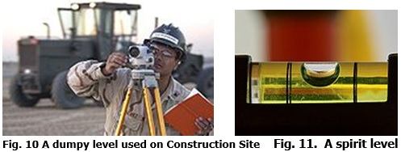

The above picture shows a dumpy level used and how the spirit level is used to show the level on the ground.
2. Level rod. it can be an aluminium or a graduated wooden. Its purpose is to give the difference in the imperial left and right metric graduation. it can either be long in length but most of them are in section for easy portage and storage. For aluminium, they are slightly different to wood. They can be adjusted by sections of telescoping. Making is made by metric unit or imperial. The following pictures shows the instrument.
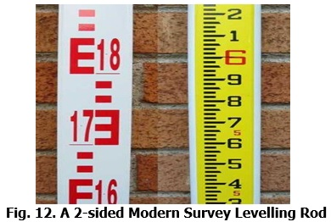

3 Hypsometer. this instrument is used to measure the altitude or the height of the ground.by sighting across a ruler, the height of a tree or a building is measured. The distance between the observer and the object should be known. By diminishing the pressure of the barometer, height makes the pressure to vary, this principle used is the boiling point. The picture below shows the hypsometer.
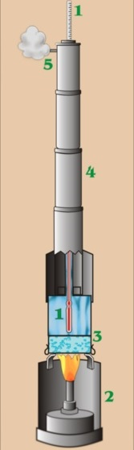

4. plane table. It is simply a plane table mounted on a sturdy base. A precise horizontal is used for levelling. Sheet used for drawing is also mounted and for easy seeing of the object intersect an alidade is used. The following pictures shows the plane table.
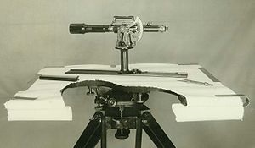

Discussion of the result
From the field work, the point of various location was collected and filled in the forms. By use of different instruments in taking the level of the ground the points were taken. By use of the various formulas various critical lengths were calculated to bring forth accuracy in the construction of the project. A level book was used to record the all the point in various column with varying descriptions. When we were calculation on the FS the IS was subtracted from the line immediately above it.
The following pictures shows all the calculations
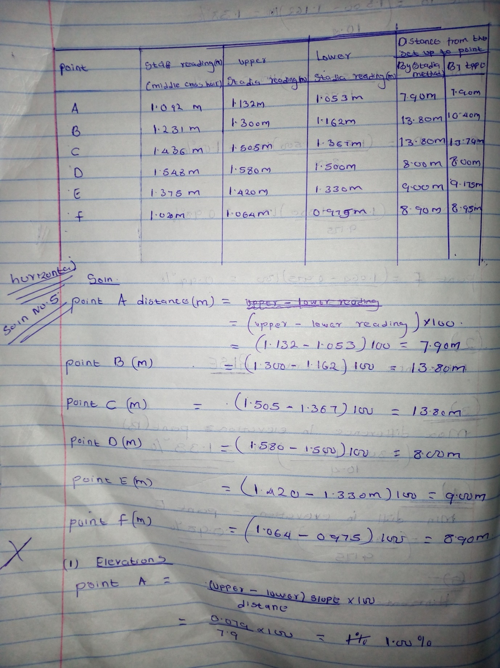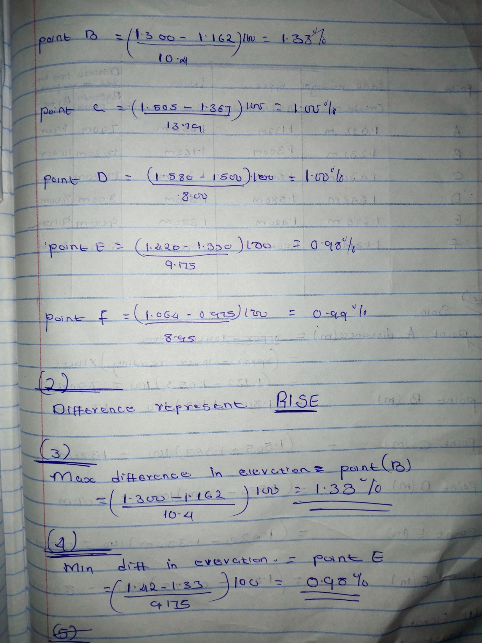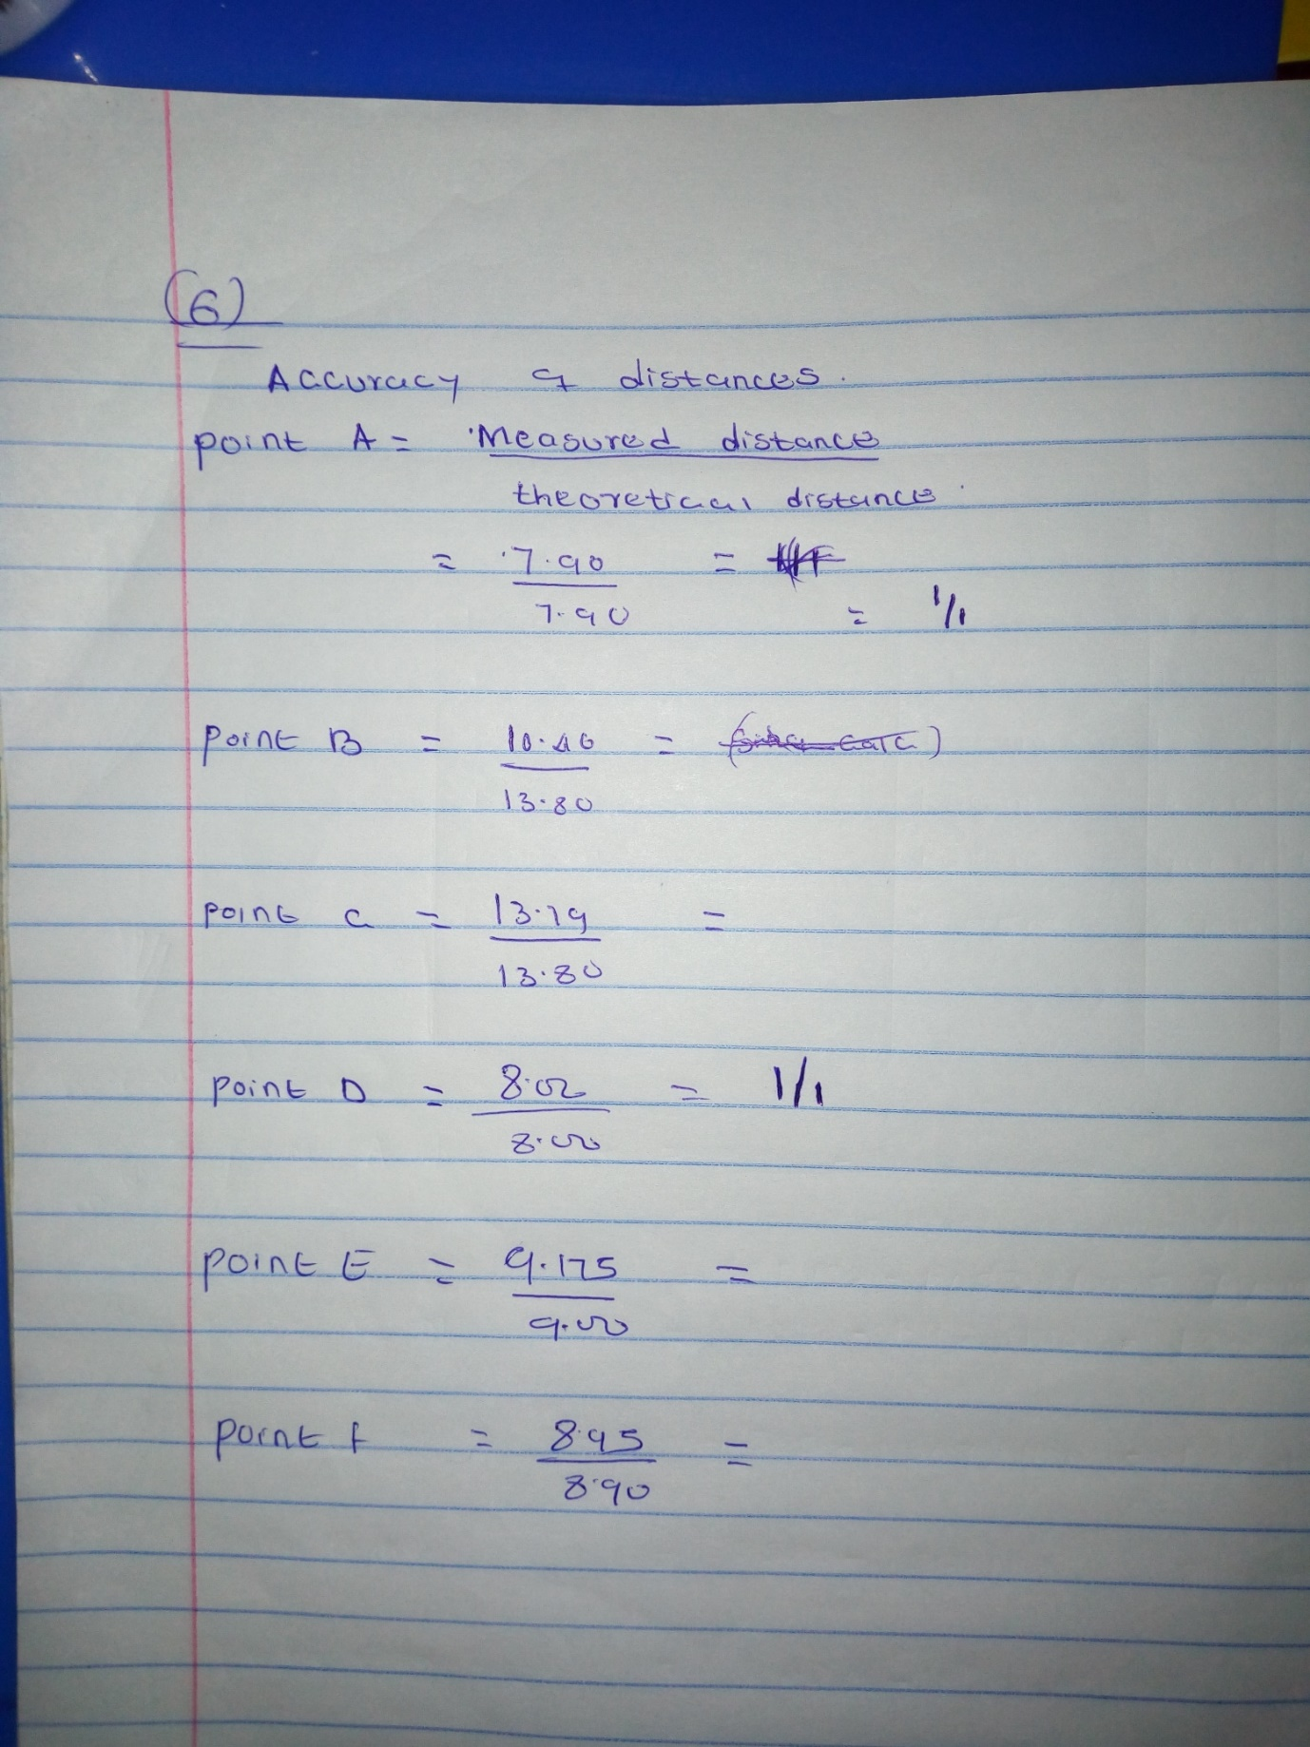
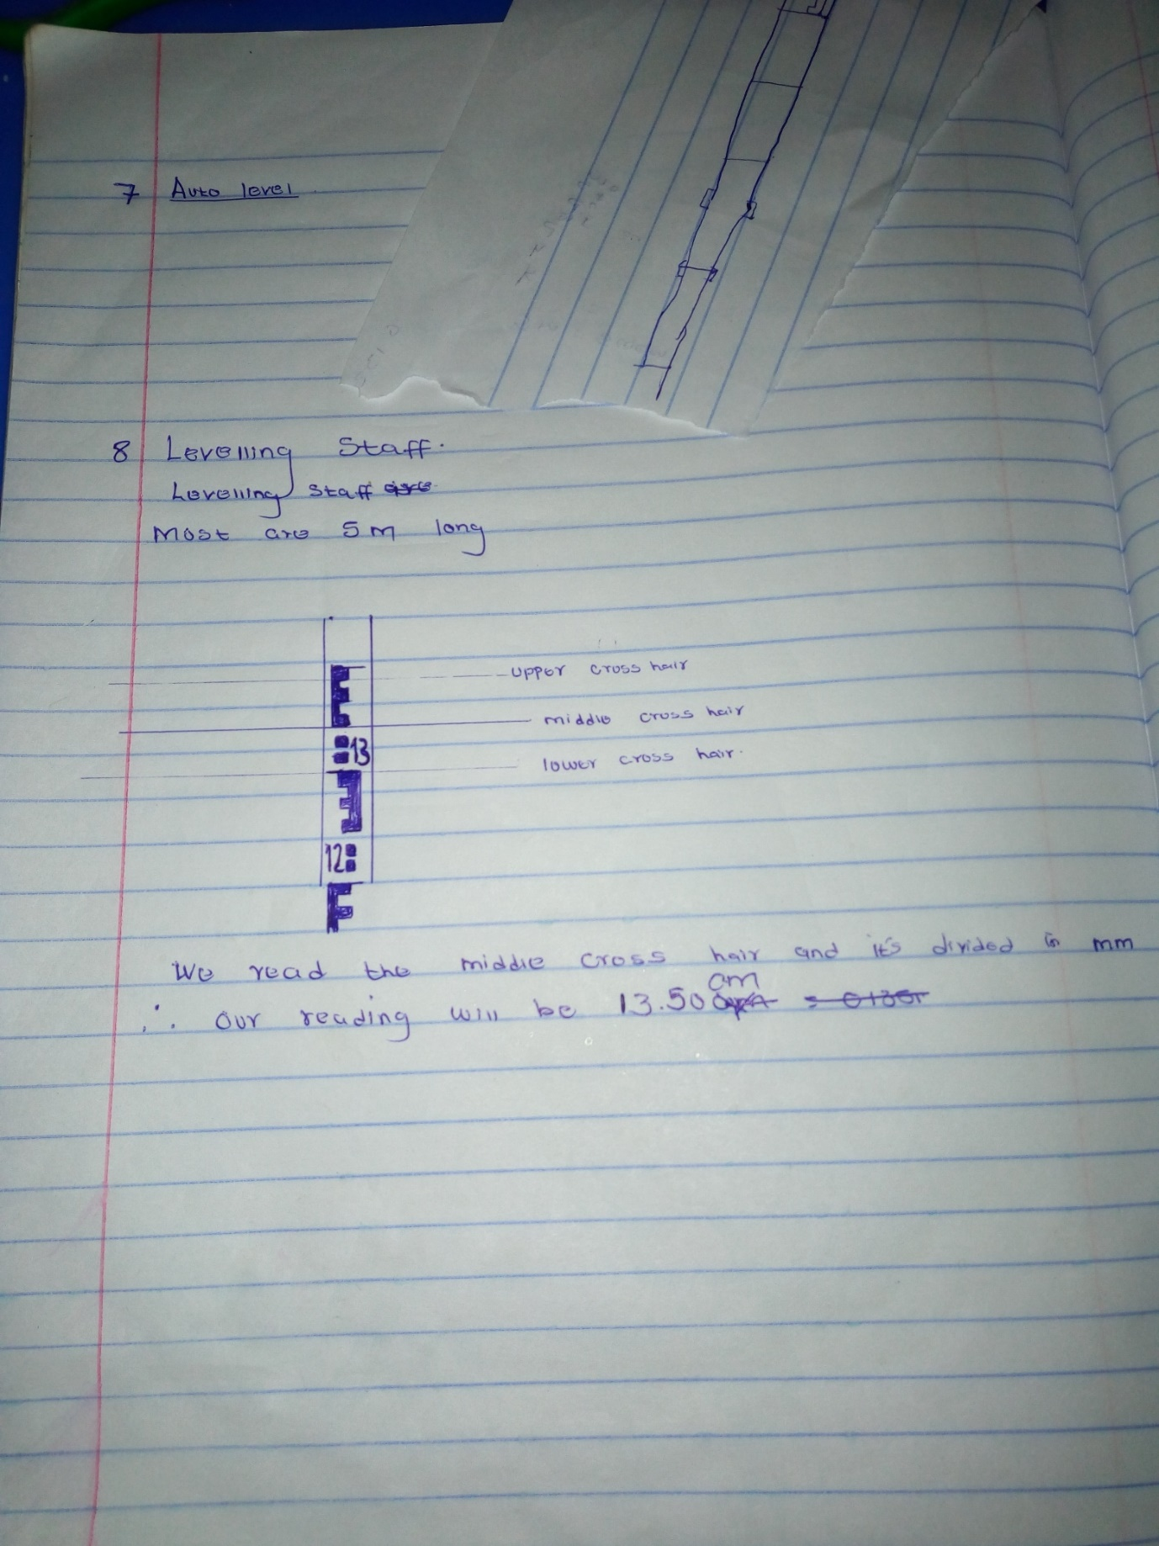

Conclusion
In a nutshell, the progress was successful since there was no any problem encountered during the field work. The points taken from different location were analysed and calculated using numerous formulas. All the data were recorded in the book field marked with different columns. We used the rise and fall methods in reading data. To verify the calculations, fly level method was used. levelling was done from known BM to unknown.

References
Pereira, V. M., & Camarena, G. (2018). Fresh and hardened properties of self-levelling mortars with porcelain and red ceramic wastes. Advances in Civil Engineering, 2018.

Piryonesi, S. M., Nasseri, M., & Ramezani, A. (2019). Resource leveling in construction projects with activity splitting and resource constraints: a simulated annealing optimization. Canadian Journal of Civil Engineering, 46(2), 81-86.

Prayogo, D., Cheng, M. Y., Wong, F. T., Tjandra, D., & Tran, D. H. (2018). Optimization model for construction project resource leveling using a novel modified symbiotic organisms search. Asian Journal of Civil Engineering, 19(5), 625-638.

Tang, Y. J., Kujawski, E., & Sztubecki, J. (2018). Improved leveling approach and its application in civil engineering. Journal of Surveying Engineering, 144(4), 06018002.
Zhi, Z., Huang, J., Guo, Y., Lu, S., & Ma, B. (2017). Effect of chemical admixtures on setting time, fluidity and mechanical properties of phosphorus gypsum based self-leveling mortar. KSCE Journal of Civil Engineering, 21(5), 1836-1843.

